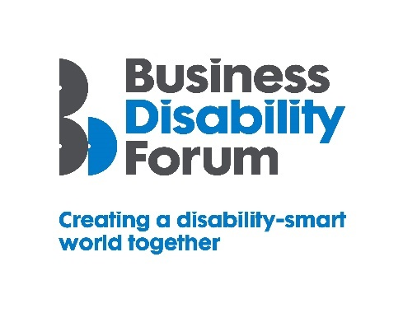
As part of this year’s Disability Smart awards, Business Disability Forum has worked with the DWP Disability Confident Team to incorporate four specific Disability Confident awards, recognising those employers that have underlined their commitment to the scheme. If your organisation would like to know more about Disability Confident and sign up to it, please follow the link:
https://disabilityconfident.campaign.gov.uk/

The Disability Confident Progress in Recruitment Award

This award will go to an organisation that has made the greatest progress in hiring disabled people into actual jobs. The organisation will be able to demonstrate tangible outcomes in terms of the numbers of disabled people in jobs and /or work-related initiatives.

The organisation will be publicly reporting around disability employment and mental health. This will include a best practice case-study example(s) that we can share with other employers (which can be anonymised).

The award-winning organisation will demonstrate real impact in one or more of the following areas:
- Innovation
- Change making

Innovation
Disability Confident employers have attracted and recruited disabled employees into real jobs and/or work-related initiatives and can demonstrate effective on-boarding processes
Originality
- What innovative practices has the organisation introduced to effectively attract and recruit disabled employees?
- Has the organisation provided opportunities such as Apprenticeships, Work Trials, Internships or other work experience?
- What on-boarding support is available for disabled employees at the induction stage and what ongoing support is available to help them progress within the organisation?
Impact/outcome
- How much of an impact has being part of Disability Confident had in attracting and recruiting disabled employees?
- How many jobs have been created and how many disabled people have been hired?
- How is the organization reporting on progress both internally and publicly?

Change making
The way in which the organisation has used the Disability Confident scheme to effect change which has resulted in employment opportunities for disabled people

Changing opinions
- How has the organisation used the Disability Confident scheme to effect change resulting in employment opportunities for disabled people?
- How have opinions changed in terms of the recruitment of disabled people?
Inspirational
- How has being signed-up to the Disability Confident scheme helped to inspire or positively change internal and external recruitment practices?
- How has the organisation inspired others to recruit more disabled people?
Influencers
- How has the organisation influenced others to report on their progress?
- How has the organisation otherwise influenced the attitudes and behaviours of other organisations in recruiting disabled people?
Lasting change
- Has the organisation employed more disabled people?
- How will being part of the Disability Confident scheme positively impact on future recruitment practices?

