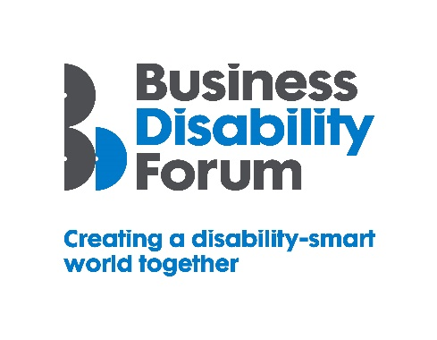
As part of this year’s Disability Smart awards, Business Disability Forum has worked with the DWP Disability Confident Team to incorporate four specific Disability Confident awards, recognising those employers that have underlined their commitment to the scheme. If your organisation would like to know more about Disability Confident and sign up to it, please follow the link:
https://disabilityconfident.campaign.gov.uk/

The Disability Confident Mental Health and Wellbeing in the Workplace Award

This award will go to a Disability Confident employer that can demonstrate that they have placed Mental Health and Wellbeing at the heart of their organisation.

They will be able to demonstrate that they are raising awareness of mental health and well-being across their organisation and have put in place appropriate help and support for their employees. This will include a best practice case-study example(s) that we can share with other employers (which can be anonymised).

The award-winning organisation will demonstrate real impact in one or more of the following areas:
- Innovation
- Inclusive design
- Breaking down barriers

Innovation
The organisation has supported employees’ mental health and wellbeing in new and innovative ways that have had a positive impact on the lives of disabled people, including people with mental health conditions.
Originality
- How has the organisation supported the mental health and wellbeing agenda?
- What adjustments to working practices have been put in place for employees experiencing mental ill health?
Impact/outcome
- How have disabled employees benefited from the introduction of innovative practices around mental health and wellbeing?
- How much of an impact will it have on the lives of disabled people going forward?
Inclusive design
The organisation has thoughtfully considered accessibility and inclusion for everyone including people with disabilities from the outset when designing how a mental health and wellbeing service or support is delivered e.g., via a website or app or delivery.
End-to-end inclusive design
- Has the organisation developed a mental health and wellbeing strategy?
- Was accessibility factored in from the outset?

Disabled users consulted
- Were disabled involved in creating what the service looked like?
- How were employees made aware of the mental health services available to them?

Trendsetting
- How has the organisation promoted the mental health and wellbeing strategy and the depth of services available?

Breaking down barriers
The organisation has removed barriers experienced by disabled people to enable everyone to access the mental health and wellbeing support they need.
Barriers removed
- Have attitudinal barriers to mental health and talking about mental health in the workplace been broken down and how?
Action
- Has the organisation introduced open and transparent conversations about mental health in the workplace?
Success
- Has the culture within the organisation improved or changed as a result of the mental health strategy?
- Has the subject of mental health in the workplace become an integral part of managers’ agendas?
- Have employees been provided with mental health and wellbeing support?

Long-term impact
- How will the organisation continue to develop the strategy and to support employees experiencing mental ill health?
- Will this have a long-term positive effect on the lives of disabled people?
- Will the employer report on disability, mental health and wellbeing?

