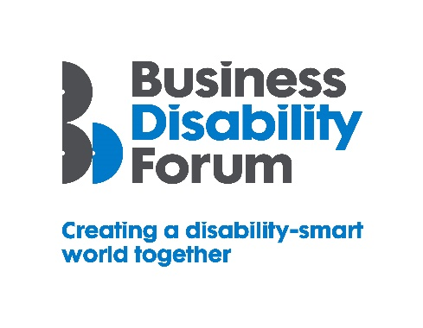
As part of this year’s Disability Smart awards, Business Disability Forum has worked with the DWP Disability Confident Team to incorporate four specific Disability Confident awards, recognising those employers that have underlined their commitment to the scheme. If your organisation would like to know more about Disability Confident and sign up to it, please follow the link:
https://disabilityconfident.campaign.gov.uk/

The Disability Confident Impact Award
This award will go to an organisation that can demonstrate that they have actively progressed through the different levels of the Disability Confident scheme.
They will also demonstrate that there has been a positive impact on the organisation in terms of disability employment and other opportunities such as apprenticeships, internships, work experience etc.
They will be actively promoting the Disability Confident scheme more widely to other employers, suppliers and stakeholders. This will include a best practice case-study example(s) that we can share with other employers (which can be anonymised).
The award-winning organisation will demonstrate real impact in one or more of the following areas:
- Change making
- Breaking down barriers

Change making
The way in which the organisation has progressed through the different levels of the Disability Confident scheme; the impact the scheme has had in providing opportunities for disabled people and the changes it has made to attitudes and behaviours.
Changing opinions
- What actions did the organisation take when progressing through the Disability Confident scheme?
- How has the organisation used the Disability Confident scheme to positively change attitudes and behaviours?

Inspirational
- Has the organisation employed more disabled people?
- Has the organisation offered work-related opportunities, such as: apprenticeships, internships or work experience?

- How has being signed-up to the Disability Confident scheme helped to inspire or positively change internal and external practices?
- How has the organisation inspired others to start the Disability Confident journey?
Influencers
- How has the organisation promoted the scheme to encourage sign-up from other employers, suppliers and stakeholders?
- How else has the organisation influenced the attitudes and behaviours of other organisations?
Lasting change
- How will being part of the Disability Confident scheme positively impact on disability employment?

Breaking down barriers
The organisation has used the Disability Confident scheme to support the removal of barriers experienced by disabled people to enable everyone to participate more fully e.g. providing inclusive recruitment, retention and progression in the workplace
Barriers removed
- How have attitudinal and behavioural barriers been broken down as the organisation has progressed through the scheme?
Action
- How has progressing through the Disability Confident scheme helped to improve work opportunities for disabled people?
Success
- How has the culture within the organisation improved or changed as a result being a Disability Confident employer?
- How did the organisation influence other organisations to sign-up to the Disability Confident scheme?

Long-term impact
- How will being part of the Disability Confident scheme have a long-term positive effect on the lives of disabled people?

