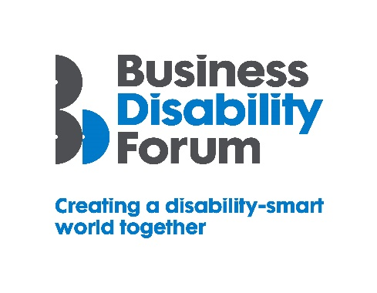
As part of this year’s Disability Smart awards, Business Disability Forum has worked with the DWP Disability Confident Team to incorporate four specific Disability Confident awards, recognising those employers that have underlined their commitment to the scheme. If your organisation would like to know more about Disability Confident and sign up to it, please follow the link:
https://disabilityconfident.campaign.gov.uk/

The Disability Confident Covid-19 Innovation Award
This award will go to a Disability Confident employer that can demonstrate that they have actively supported their disabled employees throughout the pandemic period. This could include making appropriate workplace adjustments that have enabled staff to work remotely or in a blended way, supporting them to deliver their work effectively.
We want to reward and showcase an inspirational employer that can demonstrate that they have gone the extra mile to support disabled employees.
This will include a best practice case-study example(s) that we can share with other employers (which can be anonymised).
The award-winning organisation will demonstrate real impact in one or more of the following areas:
- Innovation
- Breaking down barriers
- Change making

Innovation
The organisation has adapted their practices in new and innovative ways to ensure inclusion for disabled employees during the pandemic
Originality
- Did the organisation find new, innovative and inclusive ways to serve disabled employees?
- What workplace adjustments were put in place during the pandemic period?

Impact
- How many disabled people have benefited from the new ways of working?
- Will the new ways of working benefit more disabled people in the future?
Open doors
- Did the innovation include disabled people to engage in new ways within the organisation?
- Did it or will it create new opportunities for disabled employees?

Breaking down barriers
The organisation has removed barriers experienced by disabled people during the pandemic to enable everyone to participate more fully e.g., access services remotely via an app or website or face-to-face in a safe way.
Barriers removed
- What barriers have been broken down?
Action
- How were barriers removed?
- Were they difficult to remove before this approach?
Success
- What was the success of this approach? E.g., disabled employees being able to retain their employment and access workplace opportunities.
Long-term impact
- Will this have a long-term positive effect on the lives of disabled people? e.g. has a blended workplace approach been considered?

Change making
The way in which the organisation has worked during the pandemic has influenced, changed/helped to promote understanding and awareness of barriers disabled people experience.
Changing opinions
- How have the innovations – e.g. workplace adjustments, hybrid working or virtual service delivery - contributed to the change of opinions?
Inspirational
- Has it inspired the organisation to change its approach longer term, e.g. to blended/home working?
Influencers
- Has it influenced wider public opinion?
Lasting change
- Will it positively impact disabled employees long-term?

