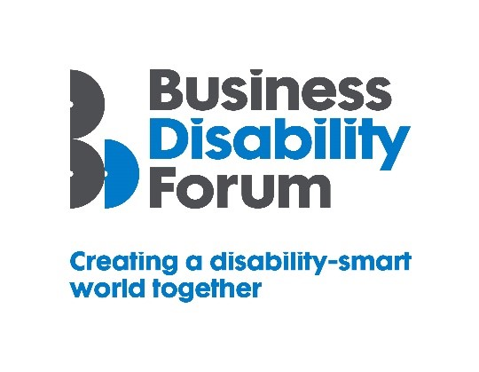
Disability Smart Workplace Experience Award
This Award will be given to an organisation that is a great place to work. We are looking for an organisation that demonstrates that it really values the physical and mental health and wellbeing of all its workers, including disabled people, and has thoughtful, engaging and inclusive workplace practices.
We want to reward and showcase a truly inclusive organisation that has gone the extra mile to break down barriers experienced by disabled people to allow them to grow, develop and thrive in the organisation.
If, despite the challenges of the past year, your organisation has effected real change and influenced tangible positive change in the workplace, wherever that might be for your workers enter for the 2021 Business Disability Forum Workplace Experience Award.
Judging Matrix:
The award-winning organisation will demonstrate real impact in one or more of the following areas:
- Innovation
- Scalability
- Inclusive design
- Breaking down barriers
- Change making

- Innovation
The organisation has introduced or developed innovative practices that improved the lives of all workers including disabled people whether they were in the workplace, out on the community or working from home.
Originality
- Has any other organisation done the same anywhere in the world?
- Did the organisation create this alone?

Impact
- How many disabled people have/will benefit from this?
- How much of an impact will it have on the lives of disabled people?
Ease of use
- How easy was it for disabled people to participate or benefit from the innovation/innovative practice?
Open doors
- Has the innovation allowed disabled people to participate more fully at work?
- Does it create new environments (actual or virtual) for disabled people to thrive in?

- Scalability
The organisation has created or improved a workplace or working experience that has the potential to improve the lives of a many people nationally or globally.
Reach
- Since the launch of the workplace or workplace experience how successful has it been in terms of people reached locally, nationally or internationally?
- Does it benefit everyone?
Potential
- How many people does this have the potential reach?
- Can it be expanded further and extended to include more groups?
Proactive scaling
- What has the business done to try to scale or reach more people?
- How flexible is it?

- Inclusive Design
The organisation has designed a workplace or workplace experience which is both beautiful and has thoughtfully considered accessibility and inclusion for everyone including people with disabilities from the outset.
End to end inclusive design
- Was accessibility factored in from the outset?
- Were disabled people involved in creating the workplace experience or environment from the outset?

Disabled users consulted
- Was it tested with disabled user groups/people?
- Did disabled users assess the useability?
Trend setting
- Something that looks good, feels good and is exciting but also inclusive.
- Does it appeal to people with different disabilities and none and from every generation?

- Breaking Down Barriers
The organisation has removed barriers experienced by disabled people to enable everyone to participate more fully in work e.g. retain employment, be more productive, develop new skills and thrive at work.
Barriers removed
- What barriers have been broken down?
- How has this helped disabled people succeed and thrive at work?
Action
- What new approach has been taken to break down the barriers?
- Were these barriers difficult to remove before this approach?
Success
- What was the success of this approach? E.g. Improved wellbeing, employee engagement and satisfaction scores, greater numbers of disabled people being promoted or participating in an area of work or the organisation that was previously inaccessible to them.
Long term impact
- Will this have a long-term positive effect on the lives of disabled people?

- Change Makers
The organisation developed or created a workplace that influences change/helps to promote understanding and awareness of barriers disabled people experience.
Changing opinions
- How has the workplace experience changed opinions?
Inspirational
- Has it inspired others to change?

Influencers
- Has it influenced the wider public opinion e.g. been in the news or shared with other organisations?
Lasting change
- Will it positively impact disabled people long term?

