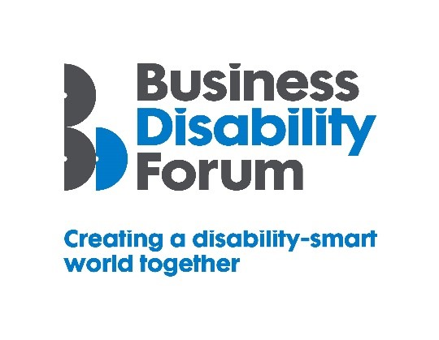
Disability Smart Workplace Adjustments Team Award
This Award will be given to a Workplace Adjustments Team that has developed and implemented a workplace adjustments process that has proven to have improved the working lives of disabled people.
We want to reward and showcase truly inclusive procedures and processes that has gone the extra mile to break down barriers experienced by disabled people.
If you work in a Workplace Adjustments Team that is a real change-maker, an influencer of tangible positive change, and a leading light in improving the lives of disabled people, submit your application for the 2021 Business Disability Forum Disability Smart Workplace Adjustments Team Award.
Judging Matrix:
The award-winning SME will demonstrate real impact in one or more of the following areas:
- Innovation
- Scalability
- Inclusive design
- Breaking down barriers
- Change making

- Innovation
The Team has developed workplace adjustments processes or procedures that are innovative, flexible and responsive and have improved the working lives of disabled people.
Originality
- Has the Team developed new and better ways of ensuring that disabled people get the adjustments that they need?
Impact
- How many disabled people will benefit from this?
- How much of an impact will it have on the lives of disabled people?
Ease of use
- Has the Team developed processes that are flexible and easy to use? Do the processes mean adjustments can be identified and implemented more quickly?
Open doors
- Do the workplace adjustments mean that disabled people can work in areas that were previously impossible or difficult?
- Does it support disabled people to progress in their careers or to move roles more easily?

- Scalability
The Team has developed a Workplace Adjustments process or improved an existing process that has the potential to improve the lives of a many people nationally or globally.
Reach
- Since the launch or development of the process or adjustment how successful has it been in terms of people reached?
- Does it benefit people locally, nationally or internationally?
- Does it benefit everyone?
Potential
- How many people does this have the potential reach?
- Can it be expanded further and extended to include more groups?
Proactive scaling
- What has the business done to try to scale or reach more people?
- How flexible is it?

- Inclusive Design
The Team has thoughtfully considered accessibility and inclusion for everyone, including people with disabilities, to allow people to work as productively as possible.

Disabled users consulted
- Were disabled people involved in the design & creation of the workplace adjustment process or procurement process if adjustments are provided by a third-party supplier/partner?
- Is feedback from users of the process regularly sought and used to improve the process?
Suppliers and partners work to same inclusion values as the organisation
- If any part of the process is outsourced is feedback provided to the supplier/partner to ensure they improve accessibility and inclusivity?

- Breaking Down Barriers
The Team has removed barriers experienced by disabled people to enable everyone to participate more fully e.g. to obtain or retain employment, be more productive, be promoted or have access to other workplace activities and opportunities such as training, wellbeing, fitness, social or other benefits.
Barriers removed
- What barriers have been broken down?
- How has this helped disabled people obtain or retain employment or work more productively or participate more fully in the working environment?
Action
- What new approach has been taken to break down the barriers?
- Were these barriers difficult to remove before this approach?
Success
- What was the success of this approach? E.g. retention or recruitment of disabled employees or participation of disabled people in an activity or an environment that was previously inaccessible.
Long term impact
- Will this have a long-term positive effect on the lives of disabled people?

- Change Makers
The Team has influenced change/helped to promote understanding and awareness of barriers disabled people experience or disability.
Changing opinions
- How has the workplace adjustments process or programme changed opinions about working with adjustments or employing disabled people?
Inspirational
- Has it inspired others to change/ask for adjustments?

Influencers
- Has it influenced other organisations to follow suit e.g. suppliers, partners or clients?
Lasting change
- Will it positively impact disabled people long-term

