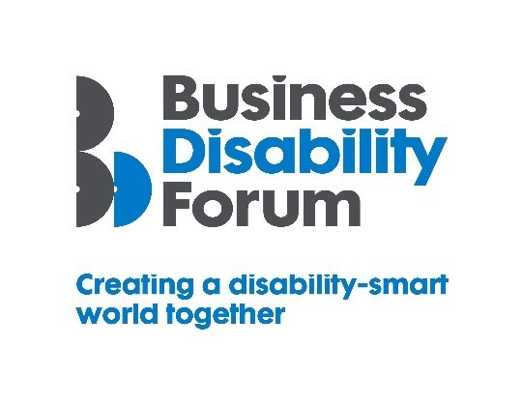
Disability Smart Technology Award
This Award will be given to developers of technology that has really improved the life chances of disabled people. We want to reward and showcase truly inclusive design or a developer that has gone the extra mile to break down barriers experienced by disabled people.
If you are a real technology change-maker, an influencer of tangible positive change, and a leading light in improving the lives of disabled people, submit your application for the 2021 Business Disability Forum Disability Smart Technology Award.
Judging Matrix:
The award-winning SME will demonstrate real impact in one or more of the following areas:
- Innovation
- Scalability
- Inclusive design
- Breaking down barriers
- Change making

- Innovation
The technology is new, innovative and improves the lives of disabled people.
Originality
- Does this technology already exist anywhere in the world?
Impact
- How many disabled people will benefit from this?
- How much of an impact will it have on the lives of disabled people?
Ease of use
- Does the technology make an everyday task easier?

Open doors
- Does the technology introduce disabled people to a part of the world that was previously inaccessible?
- Does it open up new opportunities for disabled people?

- Scalability
Technology that has been developed or existing technology that has been adapted and improved that has the potential to improve the lives of a many people nationally or globally.
Reach
- Since the launch of the technology how successful has it been in terms of people reached, locally, nationally or internationally?
- Does it benefit everyone?
Potential
- How many people does this technology have the potential reach?
- Can it be expanded further and extended to include more groups?
Proactive scaling
- What has the developer done to try to scale or reach more people?
- How flexible is it?

- Inclusive Design
Technology which is both beautiful and has had accessibility and inclusion thoughtfully embedded for everyone including people with disabilities from the outset.
End to end inclusive design
- Was accessibility factored in from the outset?
- Do they show evidence for this e.g. Have we specified the accessibility and usability features we wanted?
Disabled users consulted
- Was it designed with the involvement of disabled people?
- Was it tested with disabled people to assess the useability?
Trend setting
- Something that looks good, feels good and is exciting but also inclusive for people of all ages and with different disabilities?

- Breaking Down Barriers
Technology that has removed barriers experienced by disabled people to enable everyone to participate more fully e.g. obtain or retain employment, be more productive or be able to use a product or service fully and easily or access information or new environments or experiences.
Barriers removed
- What barriers have been broken down?
- How has this technology helped disabled people access products and services?
Action
- What new approach has been taken to break down the barriers?
- Were these barriers difficult to remove before this approach?
Success
- What was the success of this approach? E.g. retention or recruitment of disabled employees or participation of disabled people in an activity or an environment or information that was previously inaccessible.
Long term impact
- Will this have a long-term positive effect on the lives of disabled people?

- Change Makers
Technology that influences change/helps to promote understanding and awareness of barriers disabled people experience or disability.
Changing opinions
- How has the technology changed opinions?
Inspirational
- Has it inspired others to change?
Influencers
- Has it influenced the wider public opinion?
Lasting change
- Will it positively impact disabled people long term?

