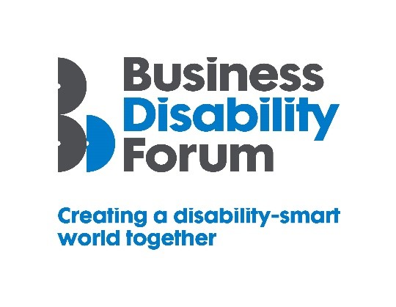
Disability Smart SME Award

This Award will be given to a Small or Medium Sized Enterprise (SME) with fewer than 250 employees and an annual turnover of less than £40 million pounds. We are looking for a business that has really improved the life chances of disabled people.
We want to reward and showcase truly inclusive design or a business that has gone the extra mile to break down barriers experienced by disabled people.
If you are a small or medium sized business that is a real change-maker, an influencer of tangible positive change, and a leading light in improving the lives of disabled people submit your application for the 2021 Business Disability Forum Disability Smart SME Award.
Judging Matrix:
The award-winning SME will demonstrate real impact in one or more of the following areas:
- Innovation
- Scalability
- Inclusive design
- Breaking down barriers
- Change making

- Innovation
The SME has developed a product or service that is new, innovative and improves the lives of disabled people.
Originality
- Does this product or service already exist anywhere in the world?
- Did the organisation create this alone?
Impact
- How many disabled people will benefit from this?
- How much of an impact will it have on the lives of disabled people?
Ease of use
- Does the product of service make an everyday task easier?
Open doors
- Does the product or service introduce disabled people to a part of the world that was previously inaccessible?
- Does it create new environments for disabled people to thrive in?

- Scalability
An SME that has developed a product or service or grown an existing product or service that has the potential to improve the lives of a many people nationally or globally.
Reach
- Since the launch of the product or service how successful has it been in terms of people reached?
- Does it benefit people locally, nationally or internationally?
- Does it benefit everyone?
Potential
- How many people does this have the potential reach?
- Can it be expanded further and extended to include more groups?
Proactive scaling
- What has the business done to try to scale or reach more people?
- How flexible is it?

- Inclusive Design
The SME has created a design which is both beautiful and has thoughtfully considered accessibility and inclusion for everyone including people with disabilities from the outset e.g. in the workplace a communication or campaign, a website or app or a product or service.
End to end inclusive design
- Was accessibility factored in from the outset?
- Do they show evidence for this e.g., we specified the accessibility and usability features we wanted
Disabled users consulted
- Was it tested with disabled user groups/people?
- Did disabled users assess the useability?
Trend setting
- Something that looks good, feels good and is exciting but also inclusive for people of all generations?

- Breaking Down Barriers
The SME has removed barriers experienced by disabled people to enable everyone to participate more fully e.g. retain employment, be more productive or be able to use a product or service fully and easily
Barriers removed
- What barriers have been broken down?
- How has this helped disabled people access products and services?
Action
- What new approach has been taken to break down the barriers?
- Were these barriers difficult to remove before this approach?
Success
- What was the success of this approach? E.g. retention or recruitment of disabled employees or participation of disabled people in an activity or an environment that was previously inaccessible.
Long term impact
- Will this have a long-term positive effect on the lives of disabled people?

- Change Makers
A campaign run by an SME that influences change/helps to promote understanding and awareness of barriers disabled people experience or disability

Changing opinions
- How has the campaign changed opinions?
Inspirational
- Has it inspired others to change?
Influencers
- Has it influenced the wider public opinion?
Lasting change
- Will it positively impact disabled people long term

