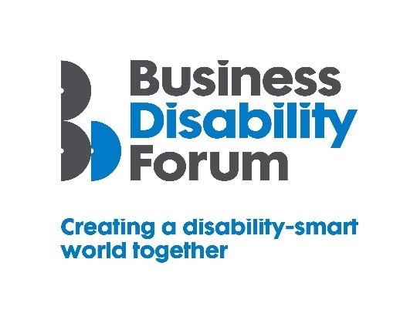
Disability Smart Procurement Team Award
This Award will be given to a Procurement Team which has made significant strides in ensuring that products and services procured from suppliers and partners are accessible and inclusive for everyone who uses them, including disabled people.
We are looking for a Team who has embedded accessibility and inclusion into contracts for products and/or services with suppliers and partners; a Team who works with suppliers and partners to help them understand what accessibility and true inclusion means.
We want to reward and showcase truly inclusive procurement and a Team that has gone the extra mile to break down barriers experienced by disabled people.
If your Team or organisation is a real change-maker, an influencer of tangible positive change, and a leading light in improving the lives of disabled people, submit your application for the 2021 Business Disability Forum Disability Smart Procurement Award.
Judging Matrix:
The award-winning organisation will demonstrate real impact in one or more of the following areas:
- Innovation
- Scalability
- Inclusive design
- Breaking down barriers
- Change making

- Innovation
The organisation/team has worked with a supplier or partner to develop a product or service that is new, innovative and inclusive and improves the lives of disabled people.
Originality
- Does this product, service or method of delivery already exist anywhere in the world?
- Did the organisation/team work with suppliers and partners to create the inclusive product or service/service delivery?
Impact
- How many disabled people will benefit from this?
- How much of an impact will it have on the lives of disabled people?
Ease of use
- Does the product of service make an everyday task easier for disabled people?
Open doors
- Does the product or service introduce disabled people to a part of the world that was previously inaccessible?
- Does it create new environments for disabled people to thrive in?

- Scalability
An organisation/team that has developed a product or service or adapted and improved an existing product or service delivered by a third party or procured from a third party that has the potential to improve the lives of a many people nationally or globally.
Reach
- Since the launch of the product or service how successful has it been in terms of people reached?
- Does it benefit people locally, nationally or internationally?
- Does it benefit everyone?
Potential
- How many people does this have the potential reach?
- Can it be expanded further and extended to include more groups?
Proactive scaling
- What has the business done to try to scale or reach more people?
- How flexible is it?

- Inclusive Design
- The organisation/team has thoughtfully considered accessibility and inclusion for everyone including people with disabilities from the outset and embedded it into the terms of delivery from the supplier or partner e.g. in contracts with occupational health providers, website or app developers, security or service providers.
End to end inclusive design
- Was accessibility and inclusion embedded into the procurement process from the outset? Do they show evidence for this e.g., we specified the accessibility and usability features we wanted.
Disabled users consulted
- Were disabled people involved in the service specification or design?
- Were disabled people involved in the procurement process? Did disabled users assess the useability and inclusivity of the product or service that was being delivered?

- Breaking Down Barriers
The organisation/team has removed barriers experienced by disabled people to enable everyone to participate more fully in the service procured or use the product procured e.g. access information via an app or website, be more productive at work or be able to use a product or service fully and easily.
Barriers removed
- What barriers have been broken down?
- How has this helped disabled people access products and services?
Action
- What new approach has been taken to break down the barriers?
- Were these barriers difficult to remove before this approach?
Success
- What was the success of this approach? E.g. retention or recruitment of disabled employees or participation of disabled people in an activity or an environment that was previously inaccessible.
Long term impact
- Will this have a long-term positive effect on the lives of disabled people?

- Change Makers
A process run by the organisation/team that influenced change/helped to promote understanding and awareness of barriers disabled people experience or disability amongst suppliers and partners and helped them to supply inclusive and accessible products and services to everyone they supply.
Changing opinions
- How has the procurement process changed opinions within the supplier or partner?
Inspirational
- Has it inspired others i.e. suppliers and partners or other departments/organisations to change?
Influencers
- Has it influenced the wider public opinion e.g. about what good looks like in a product or service?
Lasting change
- Will it positively impact disabled people long term?

