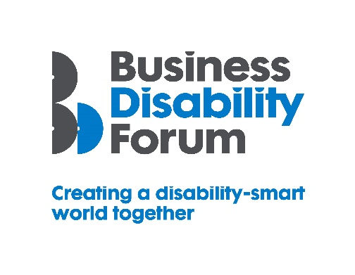
Disability Smart Learning & Development Team Award 2021
This Award will be given to a Learning & Development Team that has created innovative, engaging and most of all, inclusive and accessible learning and development solutions for everyone, including disabled people.
We want to reward and showcase truly inclusive design or a Team that has gone the extra mile to break down barriers experienced by disabled people.
If you work in a Learning & Development team that is making real changes, influencing tangible positive change, and is a leading light in improving the lives of disabled people submit your application for the 2021 Business Disability Forum Disability Smart Learning & Development Team Award.
Judging Matrix:
The award-winning Team will demonstrate real impact in one or more of the following areas:
- Innovation
- Scalability
- Inclusive design
- Breaking down barriers
- Change making

- Innovation
The Team has developed a product or service that is new, innovative and improves the lives of disabled people.
Originality
- Does this learning & development solution already exist anywhere in the world?
Impact
- How much of an impact will it have on the lives or work of disabled people? How many people will benefit?
Ease of use
- How easy is it to participate for everyone and for disabled people?
Open doors
- Does it throw open a world of learning that might otherwise have been inaccessible to disabled people?

- Scalability
A Team that has developed a product or service or adapted and improved an existing product or service that has the potential to improve the lives of a many people nationally or globally.
Reach
- Since the launch of the learning and development solution, how successful has it been in terms of people reached locally, nationally or internationally?
Potential
- How many people does this initiative have the potential reach? Can it be expanded to include more groups?
Proactive scaling
- What has the Team done to try to scale or reach more people?
- How flexible is it?

- Inclusive Design
The Team has created learning and development which is both beautifully engaging and has thoughtfully considered accessibility and inclusion for everyone including people with disabilities from the outset
End to end inclusive design
- Was accessibility factored in from the outset? E.g. did you specify the accessibility and usability features you wanted up front?
Disabled users consulted
- Was it designed with the input of disabled people?
- Was it tested with disabled people to assess the useability?
Trend setting
- Something that looks good, feels good and is exciting but also inclusive.

- Breaking Down Barriers
The Team has removed barriers experienced by disabled people to enable everyone to participate more e.g. in online or remote learning or embedded learning in day-to-day or work activities.
Barriers removed
- What barriers have been broken down?
Action
- What new approach has been taken to break down the barriers?
- Were these barriers difficult to remove before this approach?
Success
- What was the success of this approach? E.g. Qualifications attained, job entry or career progression?
Long-term impact
- Will this have a long-term positive effect on the lives of disabled people?

- Change Makers
A learning and development solution that influences change/helps to promote understanding and awareness of barriers disabled people experience or disability
Changing opinions
- How has the solution changed opinions?

Inspirational
- Has it inspired others to change?
Lasting change
- Will it positively impact disabled people long term e.g. by allowing them to obtain qualifications or access a previously inaccessible role or activity?

