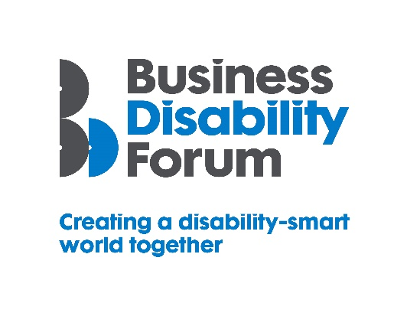
Disability Smart Environment Award
This Award will be given to an organisation that has created beautiful, accessible and inclusive physical environments for everyone, including disabled people. We are looking environments that support the physical and mental health and wellbeing of everyone who lives, works or spends time in them and that are truly inclusive.
We want to reward and showcase truly inclusive design that has gone the extra mile to break down barriers experienced by disabled people.
If the environments, you have created, have influenced tangible positive change and are leading lights in improving the lives of disabled people submit your application for the 2021 Business Disability Forum Disability Smart Environment Award.
Judging Matrix:
The award-winning SME will demonstrate real impact in one or more of the following areas:
- Innovation
- Scalability
- Inclusive design
- Breaking down barriers
- Change making

- Innovation
An environment that has new, innovative features that improve the lives of everyone, including disabled people who live, work or use them.
Originality
- Does an environment like this already exist anywhere in the world?
Impact
- How much of an impact will it have on the lives of disabled people – how many people have or will benefit?
Ease of use
- Does this environment make an everyday task easier e.g. working, shopping, travelling, resting and relaxing?
Open doors
- Do novel features of the environment mean disabled people can access parts of the world that were previously inaccessible?
- Does it create new environments for disabled people to thrive in?

- Scalability
Environmental features that have been created or adapted and improved that have the potential to improve the lives of a many people nationally or globally.
Reach
- Since the launch of the environment or environmental features how successful has it been in terms of disabled people reached locally, nationally or internationally?
- Does it benefit everyone?
Potential
- How many people does this have the potential reach?
- Can it be expanded further and extended to include more groups?
Proactive scaling
- What has the organisation done to try to scale or reach more people?
- How flexible is it?

- Inclusive Design
The organisation has designed an environment which is both beautiful and has thoughtfully considered accessibility and inclusion for everyone including people with disabilities from the outset e.g. a workplace, leisure space, living space or gathering area
End to end inclusive design
- Was accessibility factored in from the outset? E.g. did you specify the accessibility and usability features you wanted up front?
Disabled users consulted
- Were disabled people involved in the design?
- Was it tested for accessibility with disabled user groups/people?

Trend setting

- Something that looks good, feels good and is exciting but also inclusive for people of all ages, disabilities and backgrounds

- Breaking Down Barriers
The organisation has removed barriers experienced by disabled people to enable everyone to participate more fully in the environment e.g. work, play, gather, live or travel.
Barriers removed
- What barriers have been broken down?
- How has this helped disabled people access products and services?
Action
- What new approach has been taken to break down the barriers?
- Were these barriers difficult to remove before this approach?
Success
- What was the success of this approach? E.g. retention or recruitment of disabled employees or participation of disabled people in an activity or an environment that was previously inaccessible.
Long term impact
- Will this have a long-term positive effect on the lives of disabled people?

- Change Makers
An environment that encourages and influences change/helps to promote understanding and awareness of barriers disabled people experience or disability to others
Changing opinions
- How has the environment changed opinions?
Inspirational
- Has it inspired others to change?
Influencers
- Has it influenced the wider public opinion?
Lasting change
- Will it positively impact disabled people long term?

