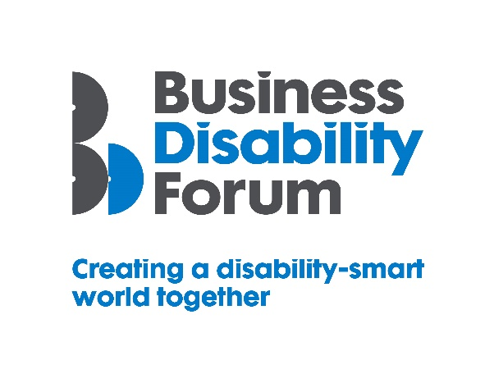
Disability Smart Diversity & Inclusion Professional Award
This Award will be given to a Diversity & Inclusion Professional who has made an outstanding contribution to furthering disability inclusion within their organisation and beyond.
We want to recognise, reward and celebrate an individual who has been working, perhaps behind the scenes and often unnoticed, to keep disability inclusion at the forefront of their organisation’s diversity and inclusion agenda.
If you know someone who, despite the challenges of the past year, has effected or influenced tangible positive change for the 2021 Disability Smart Diversity & Inclusion Professional Award.
Judging Matrix:
The award-winning organisation will demonstrate real impact in one or more of the following areas:
- Innovation
- Scalability
- Inclusive design
- Breaking down barriers
- Change making

- Innovation
The D&I Professional has developed innovative ways to raise the profile of disability inclusion in their organisation and improve the lives of disabled people.
Originality
- Has anyone else done the same anywhere in the world?
- Was this done alone or in collaboration with others?
Impact
- How many disabled people have/will benefit from this?
- How much of an impact will it have on the lives of disabled people?
Ease of use
- How easy was it for disabled people to participate or benefit from the innovation/innovative practice?
Open doors
- Has the innovation allowed disabled people to access a part of the world that was previously inaccessible?
- Does it create new environments (actual or virtual) for disabled people to thrive in?

- Scalability
The D&I Professional has helped to create or has improved a process or experience that has the potential to improve the lives of a many people nationally or globally.
Reach
- Since the launch of the process or experience how successful has it been in terms of people reached?
- Does it benefit people locally, nationally or internationally?
- Does it benefit everyone?
Potential
- How many people does this have the potential reach?
- Can it be expanded further and extended to include more groups?
Proactive scaling
- What has the business done to try to scale or reach more people?
- How flexible is it?

- Inclusive Design
The D&I Professional has designed or helped to design something which is both beautiful and which thoughtfully considers accessibility and inclusion for everyone including people with disabilities from the outset. Examples could include a learning and development initiative, workplace adjustment process, a building or physical environment, a product or service or a communication/campaign.
End to end inclusive design
- Was accessibility factored in from the outset?
- Is there evidence for this e.g., we specified the accessibility and usability features required.
Disabled users consulted
- Was it tested with disabled user groups/people?
- Did disabled users assess the useability?
Trend setting
- Something that looks good, feels good and is exciting but also inclusive.
- Does it appeal to people with different disabilities and none and from every generation?

- Breaking Down Barriers
The D&I Professional has removed barriers experienced by disabled people e.g. in obtaining or retaining employment, being more productive, developing new skills or to being able to participate in an experience or use a service or product.
Barriers removed
- What barriers have been broken down?
- How has this helped disabled people?
Action
- What new approach has been taken to break down the barriers?
- Were these barriers difficult to remove before this approach?
Success
- What was the success of this approach? E.g. greater numbers of disabled people being promoted or participating in an area of work or the organisation that was previously inaccessible to them or to use a product or service?
Long term impact
- Will this have a long-term positive effect on the lives of disabled people?

- Change Makers
The D&I Professional has influenced change/helped to promote understanding and awareness of barriers disabled people experience or disability
Changing opinions
- How have they changed opinions?
Inspirational
- Have they inspired others to change?
Influencers
- Have they influenced the wider public opinion e.g. been in the news or shared with other organisations?
Lasting change
- Will their work positively impact disabled people long term?

